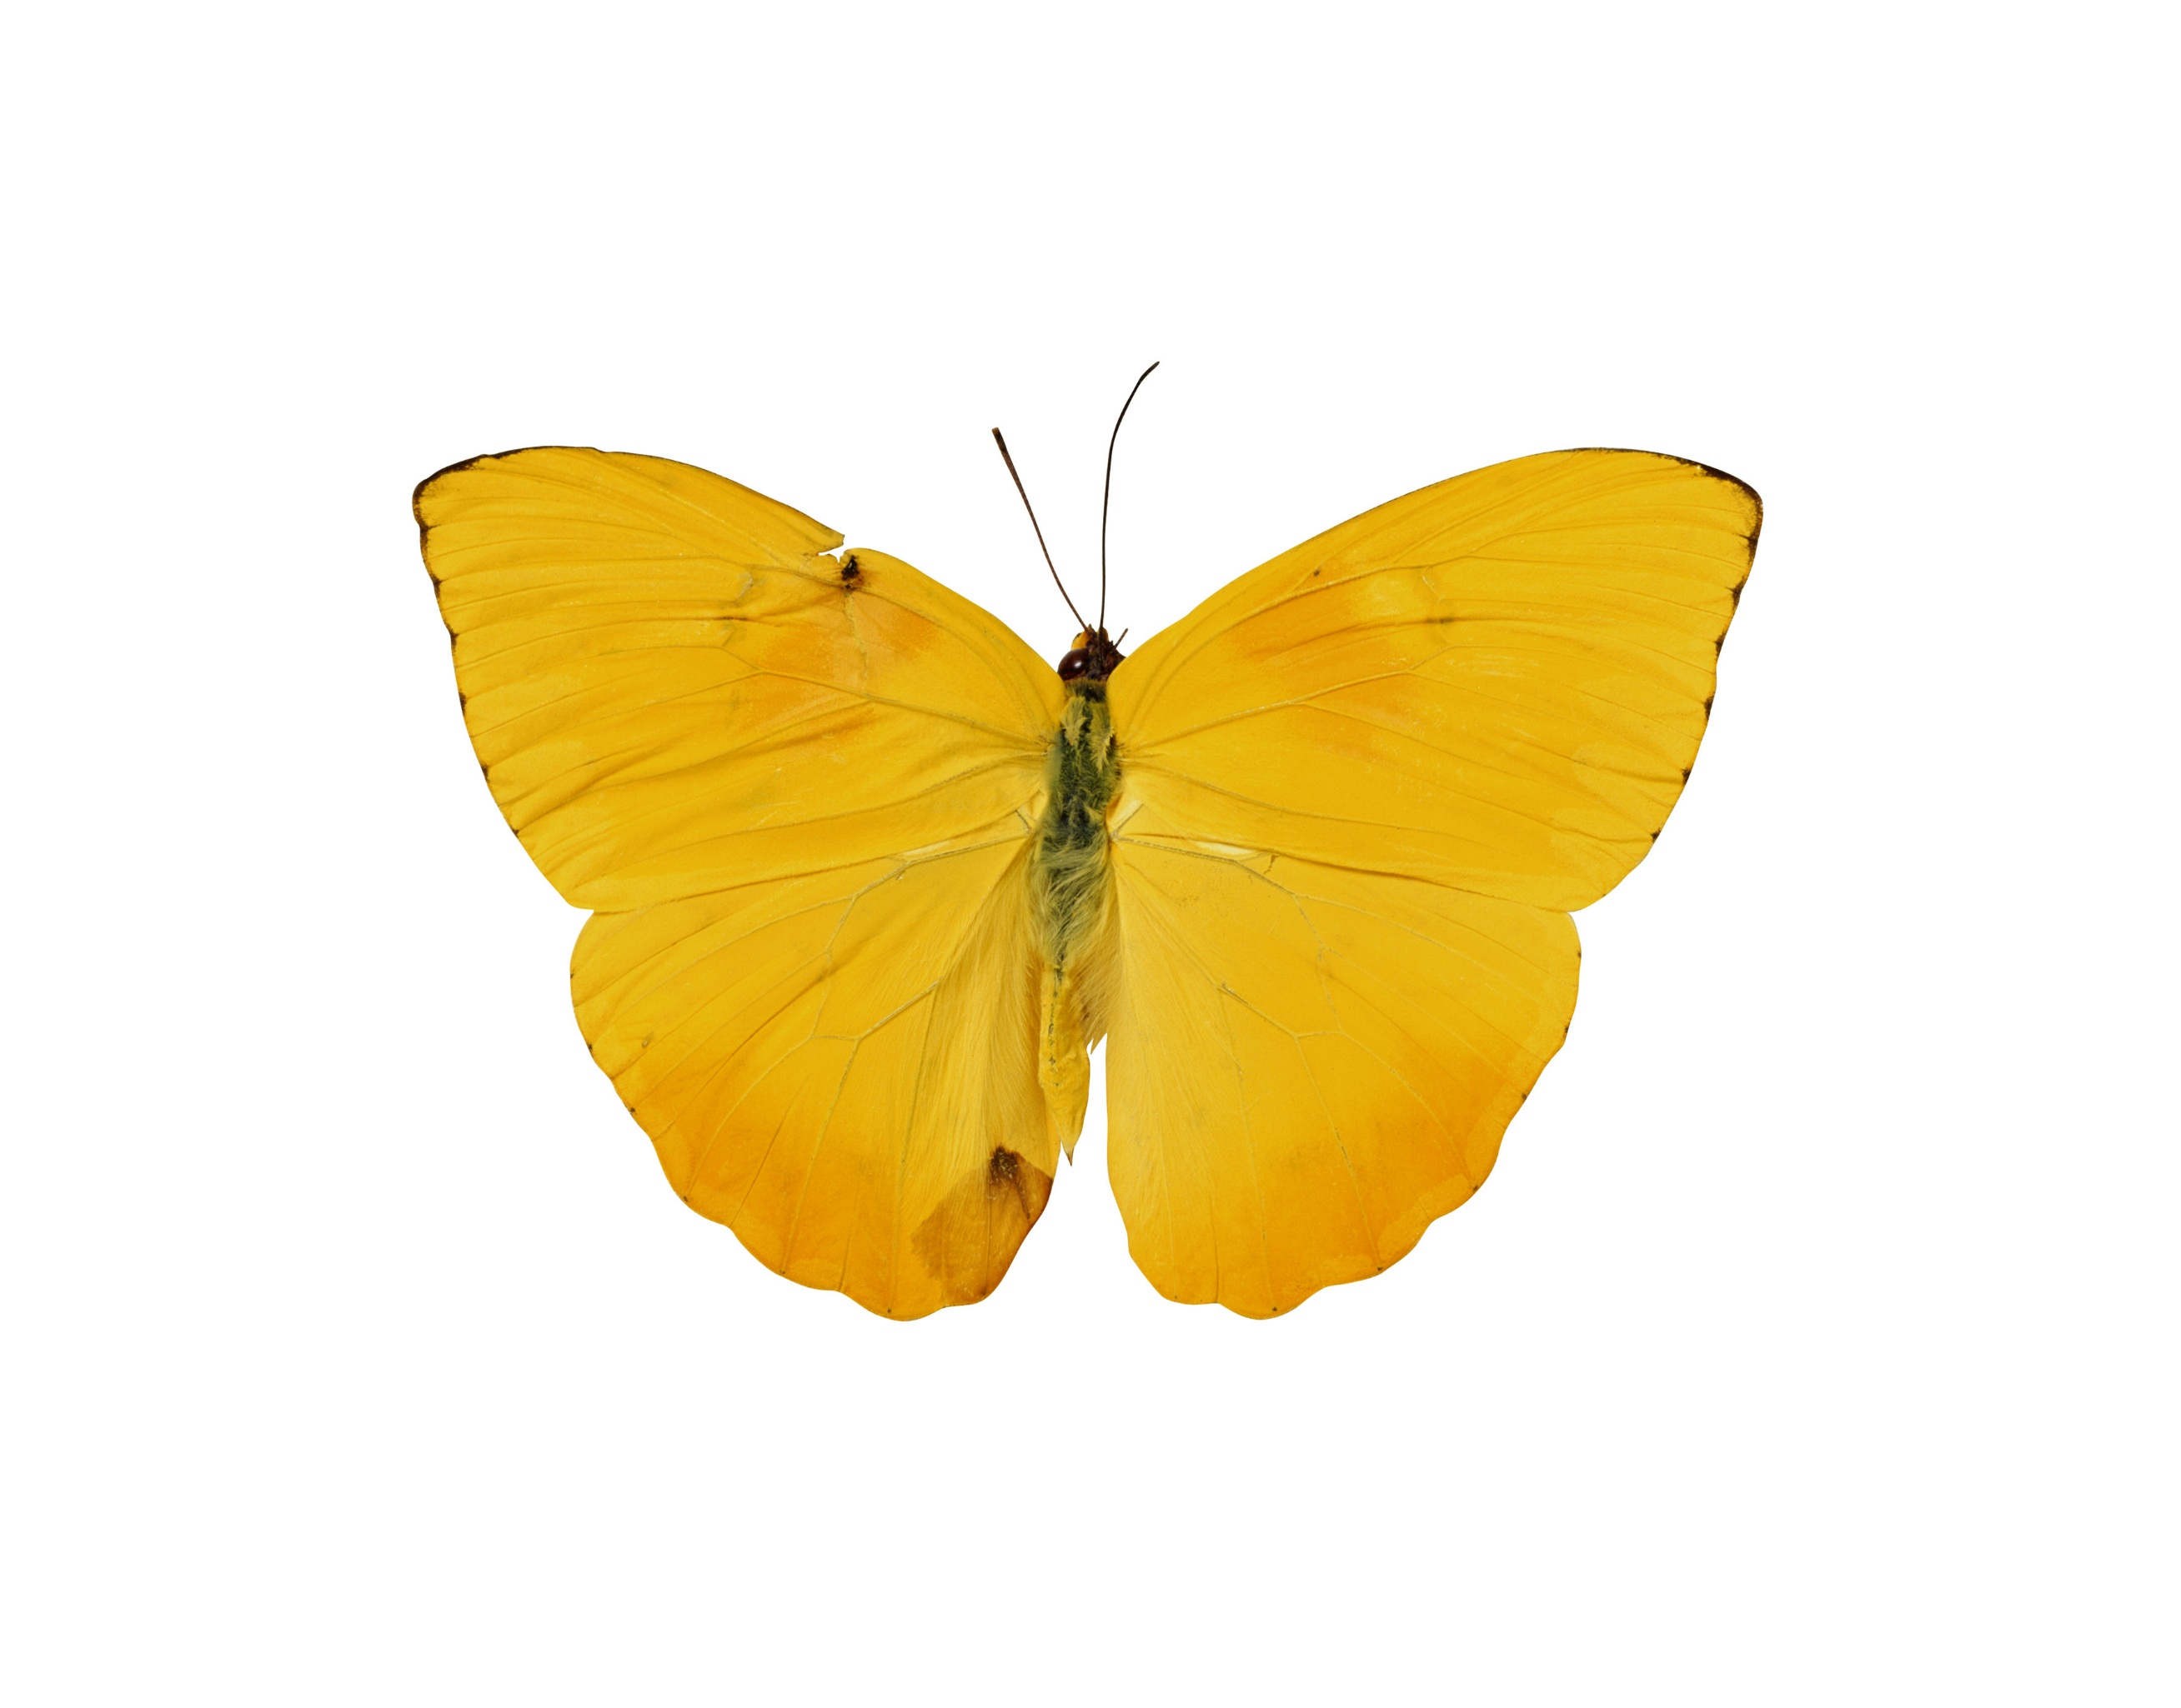

Zhejiang University  
Class Report  
2016

Synthetics Biology

# 写在前面

本课程。。。综合Wikipedia和Wikigenes的基础上，整合了班级同学的共同努力，为今后的合成生物学教学提供参考。

# 编者人员

所有编者（按姓氏拼音）：

陈鹏祥、陈颂赞、丁彦甫、高嘉豪、胡大辉、林汉扬、刘苏滢、蒋刘一琦、潘唯玮、沈浩卿、盛涛涛、冉雪彬、王紫鑫、吴芑柔、肖雨曦、薛继统、杨文君、叶青、袁略真、张霈婧、张正越、郑炯壕、仲策、周丽娜

指导教师：陈铭

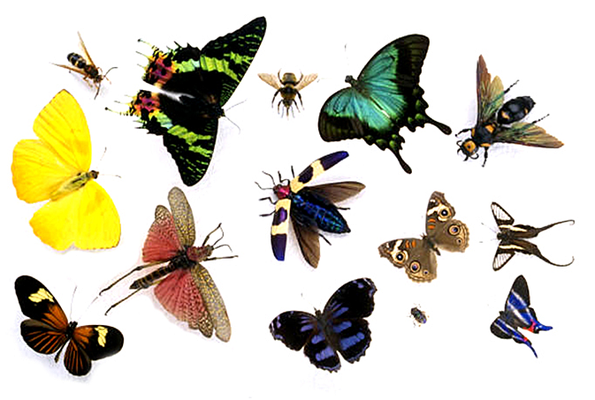

# 第一章：简介

合成生物学（SynBio）的目标是：

a) 设计和构建基于生物的部分，自然界中没有被发现的新装置和系统；

b) 出于实用的目的重新设计自然界中已经存在的生物系统。

合成生物学致力于使得生物的工程设计变得更容易和可预测，它被许多其他领域影响着，像遗传工程，生物化学，生物信息学，微生物学和纳米科技等。

欧文·薛定谔，量子力学领域一位崇高的桂冠学者，被生命如何在分子水平上创建秩序迷住了，因为宇宙中的熵是在不断增加的。此外，生物可以将这种秩序由上一代传递给下一代。他的文章《什么是生命？》鼓舞了詹姆斯·沃森和弗朗西斯·克里克，而他们后来发现了DNA。虽然我们对DNA没有一致的定义，生物学家认为DNA是能够自我复制并进行达尔文式进化的化学系统。科学家开始从系统的角度理解生命，认为生命是用砖块建造大厦，而这砖块是各种分子的复合体。因此，传统的生物学研究方法已经分离了一些基因和蛋白，以此来研究它们的结构和功能。意识到生物系统是多层次的和多尺度的帮助人们意识到生物系统不能再用简化论者的方法来学习（假设单一的生化反应产生了单一的影响）。实际上，在生物元件（比如基因和蛋白质）间存在着复杂的反应网络，伴随着正反馈和负反馈通路来调节这些元件的行为。系统的方法催生了系统生物学和合成生物学的出现。

合成生物学具有良好的应用前景，包括高效稳定地产生清洁燃料、制造生物以去除在难以接触的地方的危险废物，识别和治疗肿瘤，基于现有药物产生具有强特异性和少副作用的的新药物，利用植物感受化学刺激的特性产生相应的反馈，以及许多其他方面的应用。

在能量方面，合成生物学已经被应用于提高生物燃料的生产效率，以缓和最近的一系列问题比如土地资源紧缺。实际生产过程中，从甘蔗、棕榈等作物中获得生物燃料，生物量的浪费率达90％左右。目前正在利用合成生物学的手段改进生物燃料的生产过程，提高生物量的使用率，以实现产量和碳储蓄的显著提升。

在健康方面，合成抗疟疾药物青蒿素通过合成生物学技术进行改进，已经可以实现大规模生产，为发展中国家抗疟疾工作做出了重要贡献。同时，比尔盖茨基金会资助了这种药物的研发，相信随着这种药物的不断发展，治疗疟疾的成本会越来越低。

不论是解决现有问题还是产生新的可靠高效的解决方案，我们都不一定需要模仿自然中生物过程。我们的新设计甚至可以比进化得到的系统更加高效、坚固。

合成生物学将会对我们如何理解和处理生物系统的工程化产生巨大的影响。这个新兴领域的出现和发展会影响很多的科学和工程学科并且对社会和日常生活的各个方面都产生一定的影响。

# 2. 历史

在1980年，“合成生物学”这一术语出现于Barbara Hobom讲述使用重组DNA技术的遗传工程细菌的文献中。细菌是被人类干涉修改过（因而是合成地）的生命系统（因而是生物的）。在这一方面，合成生物学大体上与“生物工程”是同义的。在2000年，举办于San Francisco的美国化学协会年度会议上，“合成生物学”再次被Eric Kool和其他发言人提及。在此，这一术语已经与操纵于生命系统的非天然有机分子的合成相关联。更普遍地说，这一术语已经被用于尝试“重新设计生命”的参照。从这一层面上，这一术语是“仿生化学”（有机合成用于生产总结生物组件（比如酶）行为的人造分子）概念的扩展。然而合成生物学有着更宽的范围，因为它的目标是在非自然的化学系统下重新创造生命系统的突现特征（比如遗传，进化）。在2004年，一个工程师和科学家群体给予了这一术语更深远的含义，将在3.1.3 Bioparts 部分详述。据Benner和Sismour在2005年的记述：“这一组织寻求从生命系统中提取可交换的部分，这些部分可以作为结构单元被检测，验证，并能重新组装创造新的装置，新的装置可能有（或没有）生命系统的类似物。这些部分来自天然的生命系统（意味着这是生物的），而他们的组装则是非自然的。因此一个工程性的目标可能是组装生物组件（比如结合DNA蛋白质和它们结合的DNA序列）用以创造，比如用计算机输出它们的类似物。”。

# 3. 基本概念

* **3.1 合成生物学中的生物信息学和系统生物学**

随着合成生物学发展成熟成一个领域，其形成了自己的本体论和工具箱。对于大规模合成生物学应用，利用生物信息学和系统生物学通过工程化原则来计算辅助合成模块的元件的设计的趋势已然开始。这里我们回顾命名为合成生物信息学或合成系统生物学的交叉学科的进展和这一新兴领域的发展方向和趋势。

生物信息学利用生物学信息和计算方法来发现知识。应用生物信息学方法产生的结果被持续存储在组织感兴趣生物分子知识分布式信息系统中，其用来组织感兴趣生物分子知识。分布式信息系统最终编码组分（序列），结构，功能，互作，丰度等的关系。因此生物信息学的产生结果对合成生物学非常重要。同样，生物信息学的由其它理论组合的方法论给予合成生物学异极大的灵感。生物信息学致力于在给定判别准则下估计相似性和筛选结果，也致力于大数据集异质数据资源的整合和筛选出最有价值的结果。

生物信息学被期望在多种层次上给合成生物学做贡献，从成分（元件或模块）的选择和描述，到自然界启发设计原则的延伸，到创造新的方法来检验其产物。与之相反地是，合成生物学一直为生物信息学者包括研发者和使用者创造新的挑战，特别是但不局限于和系统生物学交叉的领域。

合成生物学为来自实验室或组织的生物信息学研究的模型和预测提供新的验证可能性。计算机模拟预测的有效性常常是缺乏验证的，因为其涉及产生生物系统困难的改变，而生物系统的目的是重复产生在模型中易于诱导的变化。生物元件在其中扮演着重要的角色，通过直接取代元件让这些改变可能发生，比如通路中一个部分的激活和抑制。

* 3.1.1 系统生物学与合成生物学的关系

系统生物学旨在运用仿真和建模工具和实验信息，从整体上研究自然的生物系统，通常带有特定的生物医学的关注和目的。合成生物学旨在构建新的人工生物元件、装置和系统。这两个学科运用了许多相同的方法，因此他们之间有着密切的关系。但是在合成生物学中，方法是作为工程应用的基础。定量系统生物学的基础在于信号理论，涉及离散或连续时间上的信号的分析和操作；以及工程化改造和分析生物系统，使得系统能够用数学方程来描述。一旦一个系统或是系统的元件被这样定义与描述，合成生物学就能够简化这一体系，使之成为具有输入或输出等功能特征的生物元件。就像电子元件数据手册，这些生物元件的功能特征也会被记录在特定的表内，这样系统设计者就能够理解这些元件的功能。元件将会被保存到库中。库中的元件是能够组装成为装置乃至系统的。任何的工程化的元件、装置和系统都被设计为对制造中的缺陷有一定的容错能力。生物元件比标准的工程元件有更高的容错能力，所以生物装置更具有这种容错特点。因此，合成生物学包含的是经典的简化方法，复杂的系统或过程由特定的元件或装置构成。系统生物学则是‘反简化的’或整体的。

* 3.1.2 工程设计流程和合理设计

合成生物学中一个核心的内容是那些生物学方法在工业设计和发展上广泛的应用。这种内容的本质就是描述这些元件、装置或系统的特异性，并且要求提出的设计符合这些特异性。在工程领域，系统是由标准化的装置搭建而成的，同理，装置是由标准化的元件搭建而成的。这些标准化的元件和装置的各种性质都是被充分刻画的，而且它们是可以被运用于构建复杂系统的。这种普遍的途径就是著名的工业设计流程的一部分。

我们鼓励你去看看皇家工程院绘制的名为“合成生物学范围、应用和影响”的图片。从这张图片可以看出，特异性设计的步骤后面紧接着的是复杂设计的步骤。现代设计最主要的特征之一是能够采用精细的计算机模拟。对于合成生物学，这同样至关重要。由于技术上的发展，现如今有可能实现精细的计算机模拟。所以，精确地模拟正在发展中的元件、装置和系统才变为可能。下一个阶段就是实现。（在合成生物学领域，它意味着修饰合成的DNA序列并将其插入到大肠杆菌内）在更进一步的阶段中，测试和验证对于合成生物学尤其的重要。因为生物体对于插入的细菌DNA的反应决定了特异性和设计想法是否被正确的实现了。

一个元件、装置或者系统的复杂性部分由设计流程的循环次数决定的，在循环的过程中，包含了对设计的改进和再实现。电子机械所包含的种种设计有时候被作为合成生物学概念上的各种模型。例如，一个简单的声音放大器的设计就使用到了标准化的电阻、电容和转化器。对于一个放大器存在着一整套的特异性需要设计者去遵循，并且他还需要找到相应的元件去符合这些特异性。我们还必须了解到一旦声音放大器被建造、测试、验证，它就变成一个有标准化的元件组建而成的标准化的装置，包含着它自己的特异性，同样的道理也适用于合成生物学中使用到的标准化的元件和装置。

* 3.1.3 生物元件

Biopart是生物元件,它们组合在一起形成标准化的"机器",它们可以最终放在一个标准化的系统中,实现相应的生物学功能.为了实现这一目标,需要生物元件的标准.这种标准规定了元件的框架结构,要求每一个生物元件,都要有相应的功能描述和一系列相关参数.有了这些标准,就可以让元件应用到广泛的应用领域.最终,在一定的设计下元件通过DNA拼接的方法组合在一起,以达到的特定的生物功能.

Biobricks基金会是一个由MIT，Harvard，UCSF的工程师和科学家创立的非盈利机构.它包括了由MIT维护的标准生物元件登记中心(The Registry of Standard Biological Parts),其中涵盖了生物元件和BioBricks标准的许多信息.

"Biobricks基金会的独特之处在于我们重视对生物元件标准化.这种标准化工作在之前是没人去做的.我们同时也在积极的发展生物技术的工业级标准.我们是世界第一."——BioBricks基金会

# 4. 合成生物学的方法与基本技术

合成生物学的快速发展由三项关键的技术促成——数学模型的建立、DNA的合成以及DNA测序技术。

* **4.1 数学模型的建立**

正如系统生物学，合成生物学的发展离不开生物过程的数学模型建立。近来，人们开始发展更大规模、更多层次的基因调节网络模型，以达到模拟整体基因调控网络中的生物分子相互作用，其中包括转录、翻译和基因表达调控的激活与抑制。目前有很多商业化的免费软件可供系统生物学家们使用，但是我们也注意到了合成生物学家们对整合的开发环境（IDE）的需求，例如各种工程化领域中的计算机辅助设计系统（CAD）。除了整合开发环境的需求，高通量的计算也对合成生物学的研究起到关键作用，例如使用并行计算、云计算等方式进行有效的药物发现。具体来说，模式设计、模型建立、校验合成生物学设备与系统，以及生物学参数的量化处理都是合成生物学中模型建立的重要组成部分，原因在于生物学过程的模型预测与真实情况的差异可能让我们发现对生物学过程的假设的一些缺陷，并且提示我们合成生物系统中存在的“故障”。未来，合成生物学的强力工具将帮助我们完成时间依赖的参数测量，以及大量的参数平行测量。

（合成生物学中的一些工具以及他们的应用描述已经展示在了下面的链接中：<http://www.wikigenes.org/e/art/e/187.html>）

* **4.2 DNA合成**

DNA或寡核苷酸的化学合成是合成生物学的重要组分。多亏了自动DNA合成仪的进步，现在合成和集成完整的基因、调控元件、基因回路或者整个微生物基因组已经成为可能。Khorana和他的同事们先驱性地探究了从寡核苷酸合成DNA的工作，并首次完成了一个酵母tRNA基因。这个过程也叫作基因的人工合成，因为不需要使用起始DNA模板。生长激素抑制素是第一个被化学合成的肽链，而白细胞干扰素则是第一个能在细菌里表达的人工蛋白合成基因。这些研究揭示了合成生物学的可能具有的应用。DNA的化学合成通常比重组DNA克隆更加直接经济，且被生物技术常规使用。

* **4.3 DNA测序**

首先，DNA必须要从细胞中抽提出来。这个过程可以通过机械或化学手段达到，紧接着是DNA链从结合蛋白中的纯化和分离。然后，为了得到高产的DNA克隆，它们被连接在质粒载体上，转染进可以幂数分裂的细菌或者病毒。DNA双链首先受热分离，接着发生“引物退火”现象（primerannealing），然后是在DNA聚合酶的帮助下利用脱氧核糖核苷酸（dNTP）完成DNA链的延伸。在“终止”（termination）步骤中，因为缺少DNA聚合酶工作所必需的3’端羟基，被连接上的具有荧光标记的双脱氧核糖核苷酸（ddNTP）会导致DNA链进一步延伸的终结。四个ddNTP各自被编码上不同颜色的荧光染料。为了得到不同长度的DNA链，dNTP和ddNTP的比例也需要仔细斟酌。下一步，这些混合物会流入一个带电场的毛细管中（毛细管电泳）。最小的第一个通过，最大的按顺序最后通过。通过之后，激光会激发碱基的荧光标签，同时，这一事件会被一个光电管读取并最终将信号传送到电脑。电脑会将这些“终结者”碱基解码并展示出这个特定碱基的特征峰。（图）测序按照这样的顺序完成（最小的第一个等等）。对几个生物全基因组的测序已经提供了一批丰富的信息来识别合成生物学家在其中尝试于体外构建有功能的装置的底架（chassis）（底架是合成的DNA被放置的环境或骨架）。同时，测序被用来确保编辑过的部分DNA甚至整个生物被正确地操作（例如校对）。DNA芯片便宜且迅速的DNA测序功能将帮助我们检测并定义新型的系统和生物。自人类基因组计划完成以来的这十年，我们见证了测序技术大爆发的速度之迅猛和空前的分辨率。这种测序技术的爆发使我们得以解决和提出不计其数的关于基因组的问题。测序技术似乎蓄势待发地将社会推向一个新的里程碑，因为Life Technologies公式已经宣布，运用它革命性的离子-质子技术，他们可以用一个ipad的花销测序一个人的基因组。牛津纳米孔测序法已经发明了一种以纳米孔为基础的破坏DNA链以达到测序目的的技术。这些进步将为合成生物学的进步增效。

* **4.4 DNA部件组装**

DNA装配就是采集一套双链DNA序列片段，并按照用户定义的方式将它们组合，从而产生一个组装的DNA序列。

以下为DNA部件装配方法的发展与进步，从而推断出未来的发展方向为：部件标准化，一步法（cut-ligation）以及大规模化。

* 1.传统的MCS（多克隆位点）方法

A **multiple cloning site** (**MCS**), also called a **polylinker**, is a short segment of DNA which contains many (up to ~20) restriction sites - a standard feature of engineered plasmids.[Clark 2005] Restriction sites within an MCS are typically unique, occurring only once within a given plasmid. MCSs are commonly used during procedures involving molecular cloning or subcloning. Extremely useful in biotechnology, bioengineering, and molecular genetics, MCSs let a molecular biologist insert a piece of DNA or several pieces of DNA into the region of the MCS. This can be used to create transgenic organisms, also known as genetically modified organisms (GMOs).

Clark DP (2005). Molecular Biology. Academic Press. p. 611. ISBN 0-12-175551-7.

* 2.生物砖(BioBrick)法

**BioBrick** parts are DNA sequences which conform to a [restriction-enzyme](https://en.wikipedia.org/wiki/Restriction_enzyme) assembly standard.[[1]](https://en.wikipedia.org/wiki/BioBrick#cite_note-1)[[2]](https://en.wikipedia.org/wiki/BioBrick#cite_note-Reshma-2) These building blocks are used to design and assemble larger synthetic biological circuits from individual parts and combinations of parts with defined functions, which would then be incorporated into living cells such as [*Escherichia coli*](https://en.wikipedia.org/wiki/Escherichia_coli) cells to construct new biological systems.[[3]](https://en.wikipedia.org/wiki/BioBrick#cite_note-SynBio_standards-3) Examples of BioBrick parts include [promoters](https://en.wikipedia.org/wiki/Promoter_(genetics)), [ribosomal binding sites (RBS)](https://en.wikipedia.org/wiki/Ribosomal_binding_site), [coding sequences](https://en.wikipedia.org/wiki/Coding_sequence) and [terminators](https://en.wikipedia.org/wiki/Terminator_(genetics)).

The BioBrick parts are used by applying engineering principles of abstraction and modularization. BioBrick parts form the base of the hierarchical system on which [synthetic biology](https://en.wikipedia.org/wiki/Synthetic_biology) is based. There are three levels to the hierarchy:

1. Parts: Pieces of DNA that form a functional unit (for example promoter, RBS, etc.)
2. Device: Collection set of parts with defined function. In simple terms, a set of complementary BioBrick parts put together forms a device.
3. System: Combination of a set of devices that performs high-level tasks.

The development of standardized biological parts allows for the rapid assembly of sequences. The ability to test individual parts and devices to be independently tested and characterized also improves the reliability of higher-order systems.[[4]](https://en.wikipedia.org/wiki/BioBrick#cite_note-4)（参见4.5）

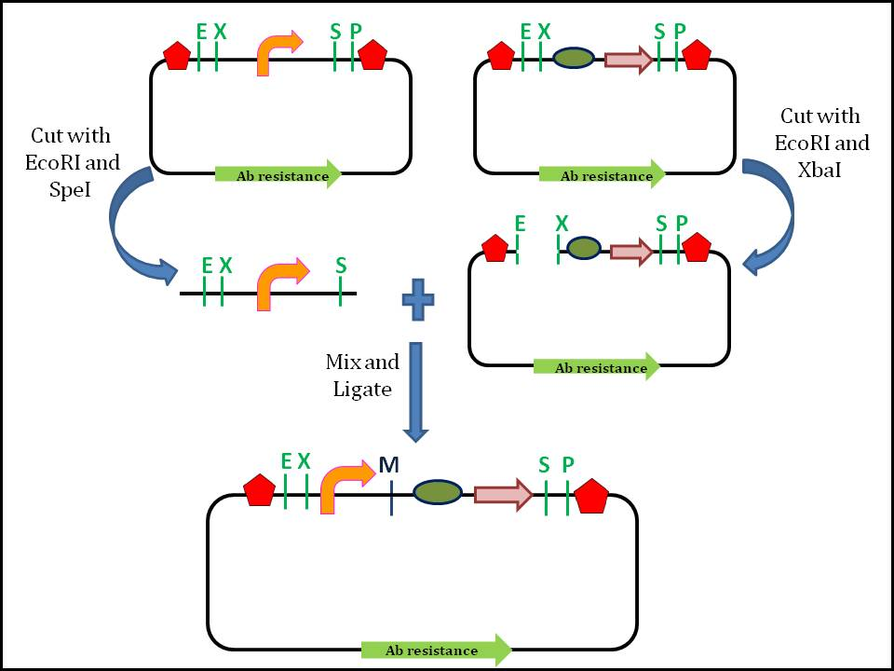

Figure. Standard assembly of two BioBrick parts (promoter and coding sequence) by digestion and ligation which forms a 'scar' site(M).

Different methods are used when it comes to assembling BioBricks. This is because, some standards require different materials and methods (use of different restriction enzymes), while others are due to preferences in protocol because some methods of assembly have higher efficiency and is user-friendly.

### 3 Antibiotic (3A) Assembly[[edit](https://en.wikipedia.org/w/index.php?title=BioBrick&action=edit&section=11)]

The 3A assembly method is the most commonly used, as its compatible with assembly Standard 10, Silver standard as well as the Freiburg standard. This assembly method involves two BioBrick parts and a destination plasmid. The destination plasmid contains the toxic(lethal) gene, to ease the selection of correctly assembled plasmid. The destination plasmid also have a different antibiotic resistance genes than the plasmids carrying the BioBrick parts. All three plasmids are digested with appropriate restriction enzyme and then allowed to ligate. Only the correctly assembled part will produce a viable composite part contained in the destination plasmid. This allows a good selection as only the correctly assembled BioBrick parts survives.

### Amplified Insert Assembly[[edit](https://en.wikipedia.org/w/index.php?title=BioBrick&action=edit&section=12)]

The amplified insert assembly method does not depend on prefix and suffix sequences, allowing to be used in combination with a majority of assembly standards. It also has a higher transformation rate than 3A assembly, and it does not require the involved plasmids to have different antibiotic resistance genes. This method reduces noise from uncut plasmids by amplifying a desired insert using PCR prior to digestion and treating the mixture with the restriction enzyme DpnI, which digests methylated DNA like plasmids. Eliminating the template plasmids with DpnI leaves only the insert to be amplified by PCR. To decrease the possibility of creating plasmids with unwanted combinations of insert and backbone, the backbone can be treated with phosphatase to prevent its religation.[[14]](https://en.wikipedia.org/wiki/BioBrick#cite_note-:0-14)

### Gibson Scarless Assembly[[edit](https://en.wikipedia.org/w/index.php?title=BioBrick&action=edit&section=13)]

The Gibson scarless assembly method allows the joining of multiple BioBricks simultaneously. This method requires the desired sequences to have an overlap of 20 to 150 [bps](https://en.wikipedia.org/wiki/Base_pair). Because BioBricks do not have this overlap, this method requires PCR primers to create overhangs between adjacent BioBricks. T5 exonuclease attacks the 5' ends of sequences, creating single-stranded DNA in the ends of all sequences where the different components are designed to anneal. DNA polymerase then adds DNA parts to gaps in the anneal components, and a Taq ligase can seal the final strands.[[14]](https://en.wikipedia.org/wiki/BioBrick#cite_note-:0-14)

* 3.SLIC，GIBSON，CPEC，USER装配方法

SLIC (sequence- and ligation-independent cloning)

[Ligation-independent cloning (LIC)](https://www.addgene.org/plasmid-protocols/lic/) was first developed in the 1990s. While traditional restriction enzyme cloning used short sticky ends, LIC employed the exonuclease activity of T4 DNA polymerase to create longer, “chewed-back” overhangs of about 10-12 bases. Only one type of dNTP would be present in the reaction mix, limiting the exonuclease activity to the first occurrence of that nucleotide. At that position, T4 would perform the favored polymerase reaction and subsequently stall due to the absence of other dNTPs. Once digested separately, the vector and insert could be annealed, forming a circular product with four nicks easily repairable by the bacteria after transformation. LIC is a reliable cloning method, but it is limited by its sequence constraints. The 10-12 base overhangs must not contain the dNTP present in the reaction, or polymerization will occur at that position, preventing T4 from chewing back the entire 10-12 bases. As such, the use of LIC is often limited to specially-designed plasmids.

In 2007, LIC received an important update, courtesy of Addgene depositor [Stephen Elledge](http://www.addgene.org/Stephen_Elledge/). His new method, named sequence- and ligation-independent cloning (SLIC), eliminates many of LIC’s constraints. Key to SLIC is the power of homologous recombination. In E. coli, a robust homologous recombination system allows for the repair of gaps and overhangs based on regions of sequence homology. This process can occur through one of two pathways: RecA-mediated recombination or RecA-independent single-stranded annealing. Elledge realized that he could generate imperfect “recombination intermediates” through PCR and imprecise T4 exonuclease activity, overcoming the requirement for carefully designed DNA overhangs used in LIC.  As long as there was enough sequence homology (20-60 bp) to organize the fragments and hold them together, E. coli would be able to “repair” the plasmid, generating recombinant DNA. Adding purified RecA to the pre-transformation incubation enhances the repair process, allowing SLIC to be used with very small amounts of DNA (e.g. 3 ng). When working with larger amounts of DNA (~100 ng,) RecA is not required.

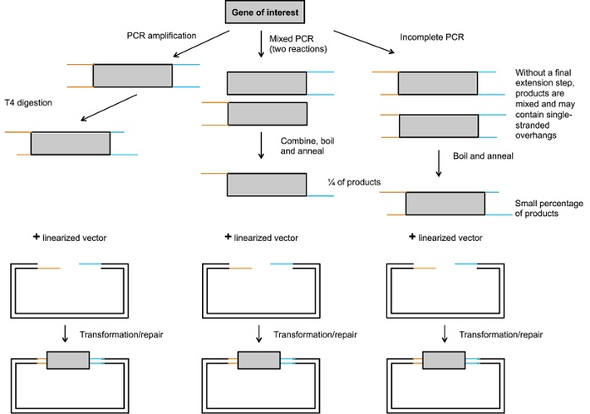

SLIC is ideal for multicomponent assembly (see figure below), as overlapping sequence homology specifies the order of multiple fragments, and the assembly is scarless. With 40 bp homology regions, a five piece assembly reaction is highly efficient (~80%.) Ten-fragment assembly can also be successful, but at a lower efficiency (~20%).

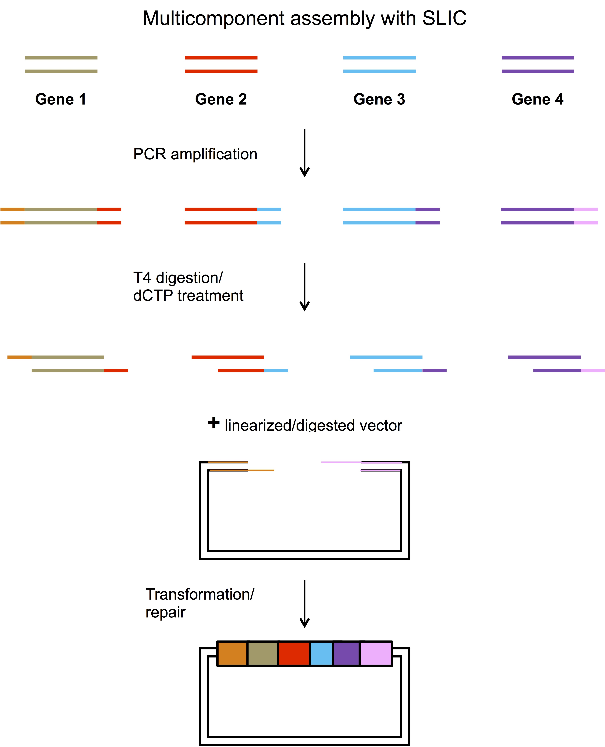

Gibson Assembly Cloning

In 2009 Dr. Daniel Gibson and colleagues at the J. Craig Venter Institute developed a novel method for the easy assembly of multiple linear DNA fragments ([Nat Methods 2009;6(5):343-5](http://www.nature.com/nmeth/journal/v6/n5/abs/nmeth.1318.html)). Regardless of fragment length or end compatibility, multiple overlapping DNA fragments can be joined in a single isothermal reaction. With the activities of three different enzymes, the product of a Gibson Assembly is a fully ligated double-stranded DNA molecule. This has proven to be an efficient and effective method for the assembly of plasmids, and molecular biologists now use this method extensively.

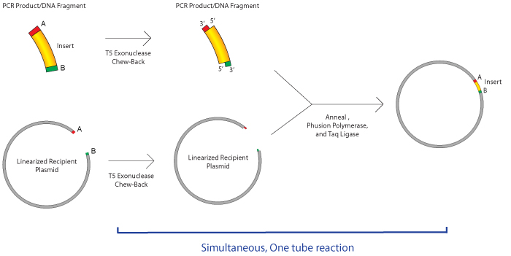

优点：

* No need for specific restriction sites. Join almost any 2 fragments regardless of sequence.
* No scar between joined fragments.
* Fewer steps. One tube reaction.
* Can combine many DNA fragments at once.
* 4.Golden Gate装配方法（以及MoClo和GoldenBraid）

Golden Gate cloning technology relies on Type IIS restriction enzymes, first discovered in 1996. Type IIS restriction enzymes are unique from "traditional" restriction enzymes in that they cleave outside of their recognition sequence, creating four base flanking overhangs. Since these overhangs are not part of the recognition sequence, they can be customized to direct assembly of DNA fragments. When designed correctly, the recognition sites do not appear in the final construct, allowing for precise, scarless cloning.

The cloning scheme is as follows: the gene of interest is designed with Type IIS sites (such as BsaI or BbsI), that are located on the outside of the cleavage site. As a result, these sites are eliminated by digestion/ligation and do not appear in the final construct. The destination vector contains sites with complementary overhangs that direct assembly of the final ligation product. As shown below, a fragment with 5’ overhang TGGA and 3’ overhang TCCG can be ligated into a vector containing those overhangs. Entry DNA overhangs may be present in the original plasmid (Option 1) or added using PCR-based amplification (Option 2).

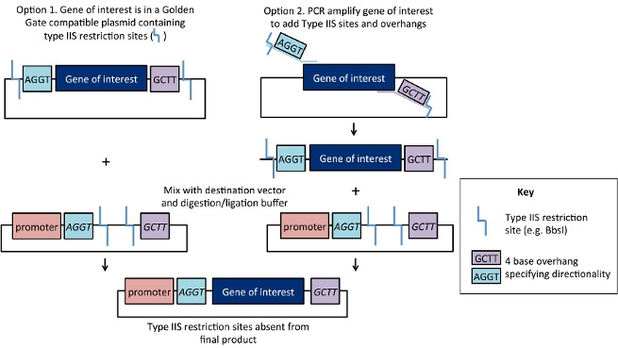

优点：

Golden Gate cloning is one of the easiest cloning methods in terms of hands-on time, as digestion and ligation can be done in one 30-minute reaction. The destination vector and entry vector(s) are placed in a single tube containing the Type IIS enzyme and ligase. Although the original destination vector + insert may spontaneously religate, this transient construct retains functional Type IIS sites and will be re-digested. In contrast, formation of the desired ligation product is irreversible because this construct does not retain the enzyme recognition sites. As a result, the ligation process is close to 100% efficient. Another strength of Golden Gate cloning is its scalability. Unique 4 base overhangs can be used to assemble multiple fragments - up to 10 fragments are commonly assembled in a single reaction! These overhangs specify the desired order of fragments, and the loss of enzyme recognition sites after ligation favors formation of the construct of interest. Although efficiency may decrease with an increased number of fragments, or the ligation of very small/very large fragments, these problems can be overcome by screening a higher number of potential clones. Golden Gate assembly has a few advantages over [other cloning methods](https://www.addgene.org/plasmid-reference/cloning-choice/#Isothermal). Exonuclease-based methods like [Gibson assembly](https://www.neb.com/products/e5510-gibson-assembly-cloning-kit?&gclid=CIHXus_SnscCFdAXHwodpU8NjQ) require 20-40 bp of homology at the ends of DNA fragments to specify assembly order, so fragments with 5’ or 3’ sequence homology cannot be assembled using this method, but can be assembled with Golden Gate. The popular [Gateway cloning system](https://www.embl.de/pepcore/pepcore_services/cloning/cloning_methods/recombination/gateway/) produces constructs with an attB recombination scar encoding eight amino acids, but Golden Gate assembly can be designed to be scarless. Golden Gate assembly is also less expensive than many commercial cloning methods.

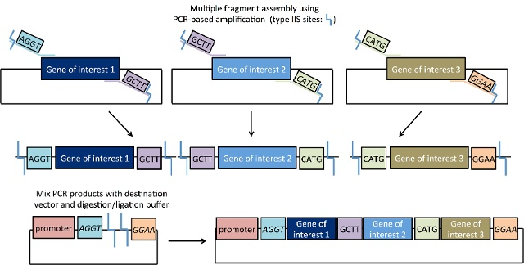

不足：

Golden Gate cloning is not 100% sequence-independent: to avoid undesired digestion, the Type IIS site used must not be present within the fragments you seek to assemble. One way to work around this is to "domesticate" your fragment: PCR-based amplification can be used to create silent point mutations at internal recognition site(s) thus eliminating these from your gene of interest. PCR products are then digested with the Type IIS enzyme, and the mixture is ligated following a heat inactivation step. If your genes of interest or destination vector contain multiple internal restriction sites that may not be amenable to "domestication", you might want to consider using an alternative method like Gateway cloning or Gibson assembly. Another important consideration is the design of flanking overhangs. Although there are theoretically 256 distinct flanking sequences, sequences that differ by only one base may result in unintended ligation products.

**Golden Gate cloning.** Engler C, Marillonnet S. *Methods Mol Biol.* 2014;1116:119-31. doi: 10.1007/978-1-62703-764-8_9.

更多信息可参考Methods in Enzymology期刊2011年497卷的合成生物学相关文章。Methods in Enzymology, Volume 497, Pages 2-662 (2011) Synthetic Biology, Part A. Edited by Chris Voigt, ISBN: 978-0-12-385075-1.

* **4.5 DNA元件分析和描述标准**

## BioBrick Assembly standard[[edit](https://en.wikipedia.org/w/index.php?title=BioBrick&action=edit&section=5)]

The BioBrick assembly standard was introduced to overcome the lack of standardization posed by traditional [molecular cloning](https://en.wikipedia.org/wiki/Molecular_cloning) methods. The BioBrick assembly standard is a more reliable approach for combining parts to form larger composites. The assembly standard enables two groups of synthetic biologists in different parts of the world to re-use a BioBrick part without going through the whole cycle of design and manipulation.[[2]](https://en.wikipedia.org/wiki/BioBrick#cite_note-Reshma-2) This means the newly designed part can be used by other teams of researchers more easily. Besides that, when compared to the old-fashioned *ad hoc* cloning method, the assembly standard process is faster and promotes automation.[[11]](https://en.wikipedia.org/wiki/BioBrick#cite_note-The_BioBrick_approach-11) The BioBrick assembly standard 10 was the first assembly standard to be introduced. Over the years, several other assembly standards, such as the Biofusion standard and Freiburg standard have been developed.

## Parts Registry[[edit](https://en.wikipedia.org/w/index.php?title=BioBrick&action=edit&section=14)]

The MIT group led by Tom Knight that developed BioBricks and [International Genetically Engineered Machines (iGEM)](http://igem.org/Main_Page) competition are also the pioneers of The Registry of Standard Biological Parts (Registry).[[17]](https://en.wikipedia.org/wiki/BioBrick#cite_note-A_primer-17) Registry being one of the foundations of synthetic biology, provides web-based information and data on over 20,000 BioBrick parts. The Registry contains:

* Information and characterisation data for all parts, device and system
* Includes a catalogue which describes the function, performance and design of each part

Every BioBrick part has its unique identification code which makes the search for the desired BioBrick part easier (for example, BBa_J23100, a constitutive promoter).[[2]](https://en.wikipedia.org/wiki/BioBrick#cite_note-Reshma-2) The registry is open access, whereby anyone can submit a BioBrick part. Most of the BioBrick submission is from students participating in the annual iGEM competition hosted every summer.[[18]](https://en.wikipedia.org/wiki/BioBrick#cite_note-18) The Registry allows exchange of data and materials online which allows rapid re-use and modifications of parts by the participating community.

Professional parts registries have also been developed. Since most of the BioBrick parts are submitted by undergraduates as part of the iGEM competition, the parts may lack important characterisation data and metadata which would be essential when it comes to designing and modelling the functional components.[[17]](https://en.wikipedia.org/wiki/BioBrick#cite_note-A_primer-17) One example of a professional parts registry is the USA-based publicly funded facility, [The International Open Facility Advancing Biotechnology (BIOFAB)](http://biofab.synberc.org/), which contains detailed descriptions of each biological part. It is also an open-source registry, and is available commercially. BIOFAB aims to catalogue high-quality BioBrick parts to accommodate the needs of professional synthetic biology community.

The [BioBrick Foundation (BBF)](http://biobricks.org/) is a public-benefit organization established to promote the use of standardized BioBrick parts on a scale beyond the iGEM competition. The BBF is currently working on the derivation of standard framework to promote the production high quality BioBrick parts which would be freely available to everyone.[[19]](https://en.wikipedia.org/wiki/BioBrick#cite_note-BBF-19)

* **4.6 DNA阵列**

真核细胞基因表达是一个动态过程，涉及到基因调控网络（GRN）的复杂互作。为了发展合成生物学，我们需要理解这些网络的设计原理。微阵列、基因芯片主要是由已知的cDNA（互补DNA）或数以千计的基因的寡核苷酸序列排列在芯片上组成的，广泛用于基因表达分析（详细见动画）。这种方法是将来源于多种生物样本的经标记的cDNA杂交成基因芯片。接着进行荧光检测以及定量数据分析来显示差异表达。在一个单一平台上，微阵列能同步、定量地检测数以千计的基因表达情况以响应多个实验变量。基因表达的数据集经过聚类算法显示基因的共表达（同时下调或上调）和离散网络调控。

# 5. 生物网络和环路

* **5.1 调控和代谢环路的概念**
* **5.2 振荡器**

http://rsif.royalsocietypublishing.org/content/7/52/1503

5.2.1 振荡器的类型

5.2.1.1Goodwin震荡器（Goodwin oscillator）

The Goodwin oscillator, conceived over 40 years ago ([**Goodwin 1963**](http://rsif.royalsocietypublishing.org/content/7/52/1503#ref-20)), was the first synthetic genetic oscillator to be studied. It is also the simplest oscillator, comprising a single gene that represses itself ([**figure 1**](http://rsif.royalsocietypublishing.org/content/7/52/1503#F1)a).

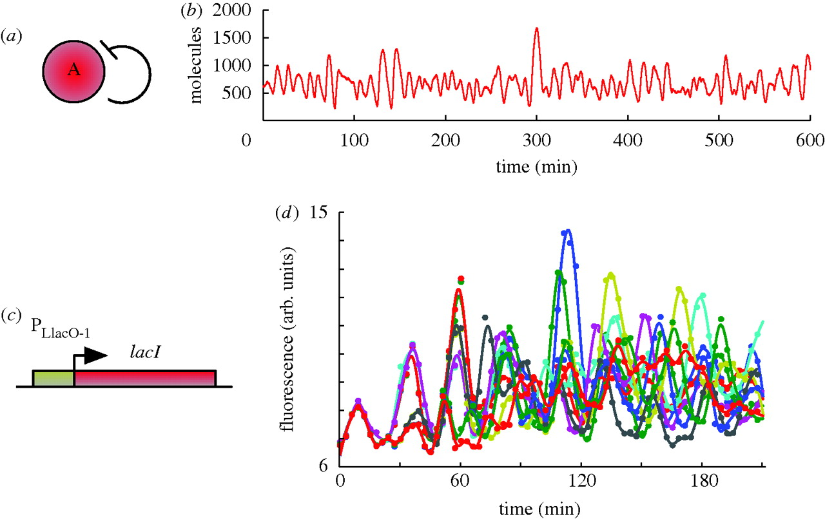

**Figure 1.**

(*a*) Goodwin oscillator topology. It comprises a single gene that represses itself. Throughout the text, the convention used is that a solid line indicates direct transcriptional control, while dotted lines indicate an alternative or indirect regulatory mechanism. (*b*) Gillespie simulation of a Goodwin oscillator model. (*c*) *In vivo* implementation. The PLlacO-1 promoter ([**Lutz & Bujard 1997**](http://rsif.royalsocietypublishing.org/content/7/52/1503#ref-30); also employed in the construction of Elowitz's repressilator, see §3.3), active in the absence of LacI, was used to control LacI expression. (*d*) *In vivo* time series of GFP fluorescence. Figure (*b*) and (*d*) are adapted from [**Stricker *et al.* (2008)**](http://rsif.royalsocietypublishing.org/content/7/52/1503#ref-48).

5.2.1.1抑制震荡器（Represillator）

A repressilator can be thought of as an extension of the Goodwin oscillator. It is defined as a regulatory network of one or more genes, with each gene repressing its successor in the cycle ([**Müller et al. 2006**](http://rsif.royalsocietypublishing.org/content/7/52/1503#ref-35)). The term was first used to describe a cycle of three genes ([**Elowitz & Leibler 2000**](http://rsif.royalsocietypublishing.org/content/7/52/1503#ref-11); [**figure 2**](http://rsif.royalsocietypublishing.org/content/7/52/1503#F2)a).

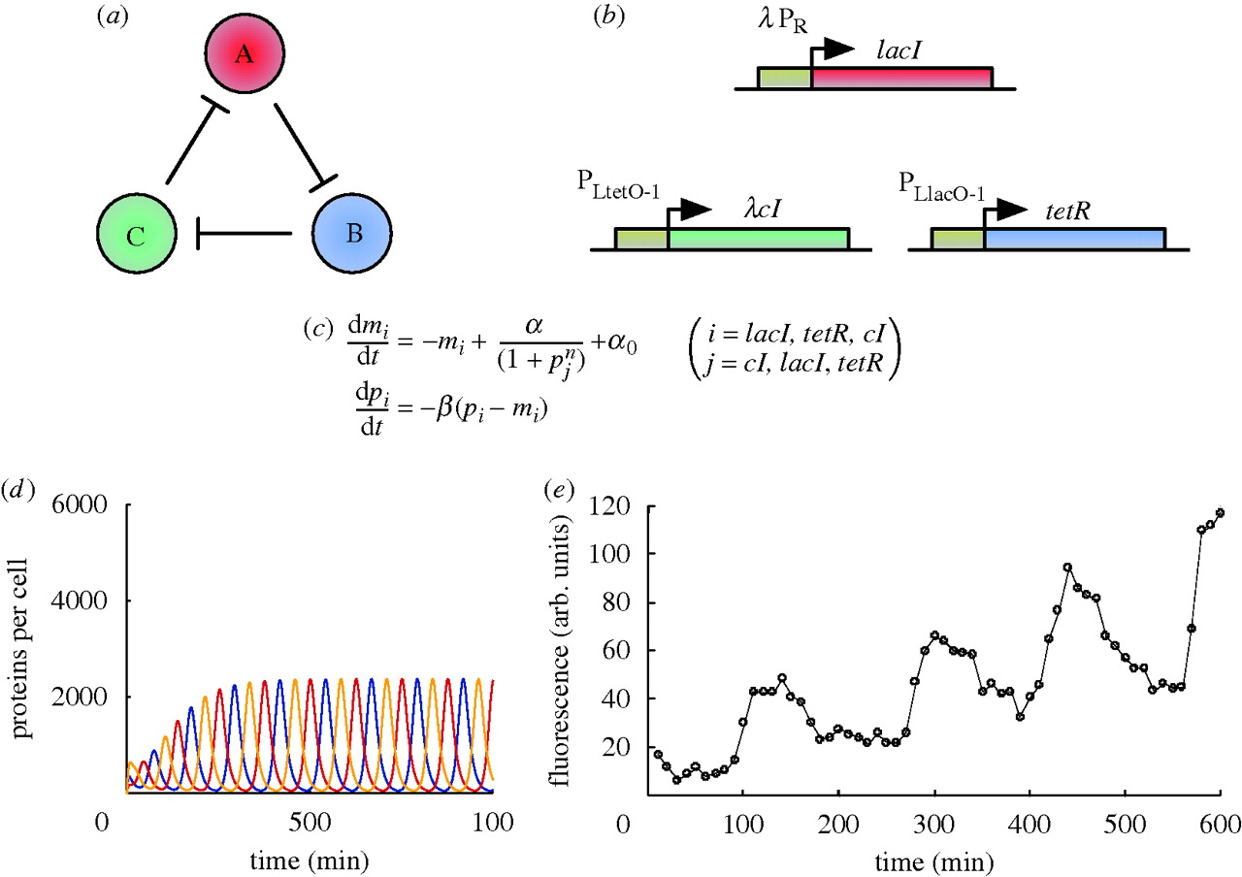

**Figure 2.**

(*a*) Three-gene repressilator topology. Each gene represses its successor in the cycle. (*b*) *In vivo* implementation of a three-gene repressilator. LacI represses *tetR* through PLlacO-1, tetR represses *λ* *cI* through PLtetO-1 and cI represses *lacI* through *λ* PR, completing the cycle. All genes contain an ssrA sequence tag to promote rapid degradation. (*c*) ODE model equations for the *in vivo* implementation. *mi* and *pi* represent mRNA and protein concentrations, respectively, *i* and *j* paired order-wise, resulting in six ODEs. *α*0 and *α* + *α*0 are the number of protein copies produced per cell with saturating repressor levels (promoter ‘leakyness’) and without repressor, respectively. *β* is the ratio of the protein decay rate to the mRNA decay rate and *n* the Hill coefficient. (*d*) Time series obtained by *in silico* simulation of ODEs for a particular set of parameters (see [**Elowitz & Leibler (2000)**](http://rsif.royalsocietypublishing.org/content/7/52/1503#ref-11) for details). (*e*) *In vivo* time series of GFP fluorescence. Figure (*d*) and (*e*) are adapted from [**Elowitz & Leibler (2000)**](http://rsif.royalsocietypublishing.org/content/7/52/1503#ref-11).

[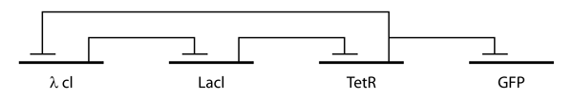](https://en.wikipedia.org/wiki/File:Repressilator_GRN.png)

Figure *. The repressilator genetic regulatory network

[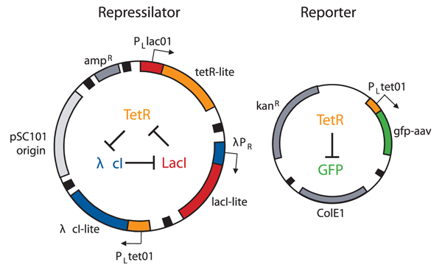](https://en.wikipedia.org/wiki/File:Repressilator_plasmid.png)

The plasmids used to implement the repressilator in *Escherichia coli*.

5.2.1.2 Atkinson振荡器Amplified negative feedback oscillators

The Goodwin oscillator and the repressilators are formed from solely repressive links. The logical next step in oscillator design was to explore oscillators also incorporating activating links between genes. The amplified negative feedback oscillator comprising two genes is possibly the simplest type of amplified negative feedback oscillator. Here, one gene promotes (amplifies) its own transcription via a positive self-feedback loop and also activates transcription of the other gene. At the same time, the second gene represses transcription of the first gene, forming a negative feedback loop ([**figure 3**](http://rsif.royalsocietypublishing.org/content/7/52/1503#F3)a).

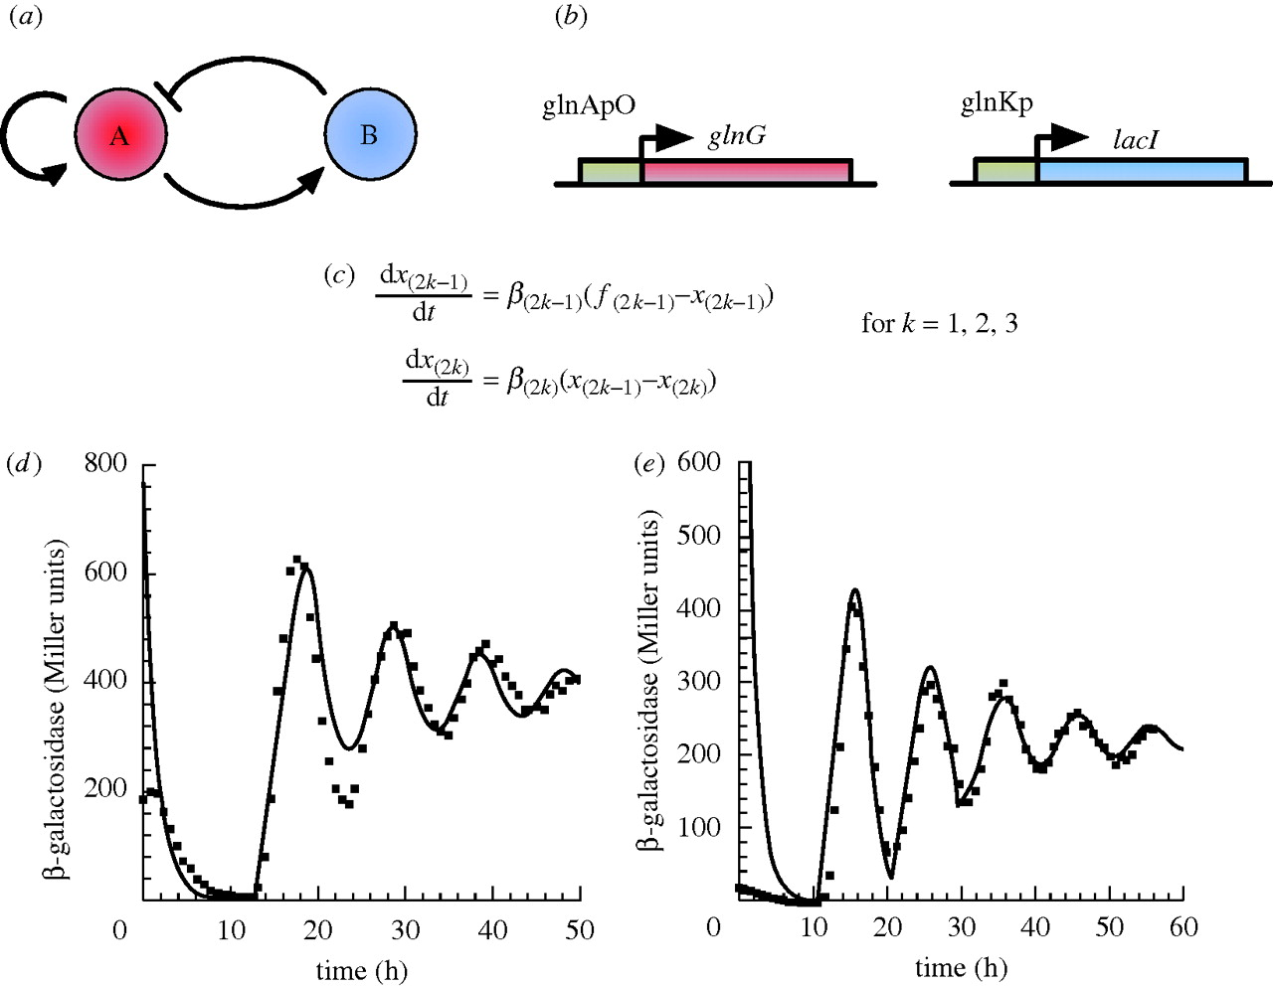

**Figure 3.**

1. Amplified negative feedback topology, with repression by transcriptional control. Gene A activates its own transcription and that of gene B, while B represses transcription from A. (*b*) *In vivo* implementation. Details provided in the main text. (*c*) ODE model equations for the *in vivo* implementation. *xi* represent concentrations of network components (normalized with respect to their steady-state values), odd and even numbered variables describe mRNA and protein concentrations, respectively. The model comprises six ODEs, two describing the reporter LacZ. *fi* are tri-phasic transcriptional rates (see electronic supplementary material, §S3.2), while *βi* are constants describing numerous rates. (*d*) *In vivo* (squares) and simulation (solid lines) time series for the three-cycle implementation. β-Galactosidase is encoded by the *lacZ* reporter encoded as part of the *lacYZA* operon on the *E. coli* chromosome, but under the control of the oscillator. (*e*) *In vivo* and simulation time series for the four-cycle implementation. Figure (*d*) and (*e*) are adapted from [**Atkinson *et al.* (2003)**](http://rsif.royalsocietypublishing.org/content/7/52/1503#ref-2).

5.2.1.3器Fussenegger oscillators

The Fussenegger oscillators are the only oscillators to have been implemented in a eukaryotic system. This is an important step towards using eukaryotic cells as hosts for more complex networks and for exploiting the powerful but often subtle regulatory mechanisms they possess. The original Fussenegger oscillator ([**Tigges et al. 2009**](http://rsif.royalsocietypublishing.org/content/7/52/1503#ref-49)) comprises two genes, with both sense and antisense transcription occurring from one of them. The sense transcript is translated, the resulting protein feeding back to itself by promoting transcription, and also activating the second gene. In a first for a synthetic genetic network, this second gene activates antisense transcription from the first gene, the transcript not translated, instead hybridizing with the sense transcript, repressing sense protein production at translation. This completes a negative feedback loop ([**figure 6**](http://rsif.royalsocietypublishing.org/content/7/52/1503#F6)a). The Fussenegger oscillator is therefore an amplified negative feedback oscillator ([**figure 6**](http://rsif.royalsocietypublishing.org/content/7/52/1503#F6)b). However, importantly, in comparison to the previous negative feedback oscillators, it contains an additional step in the negative feedback loop that ‘delays’ the repressive effect.

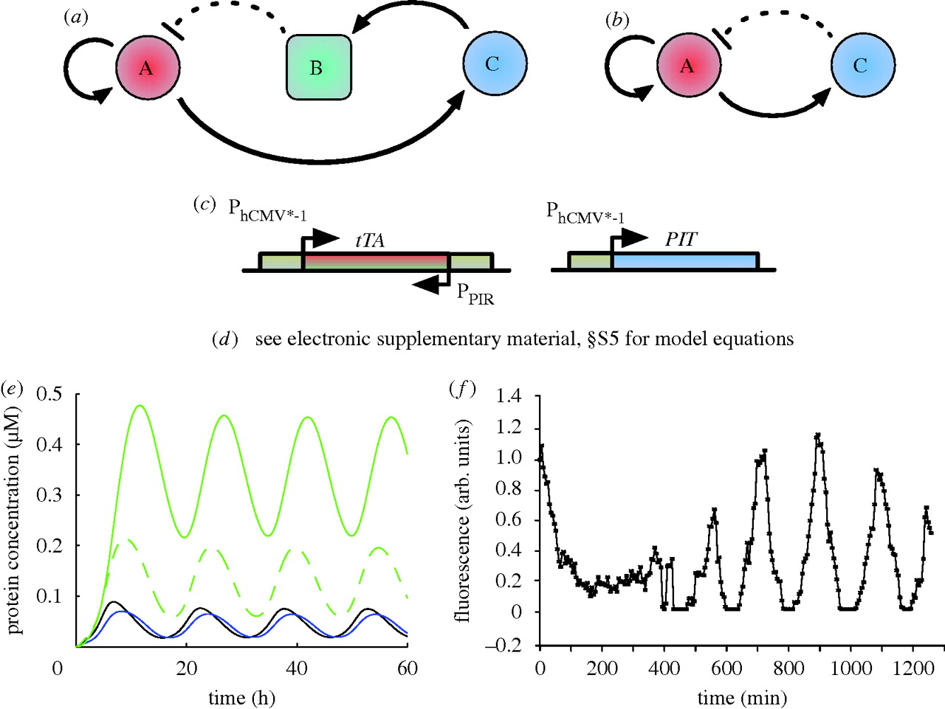

**Figure 6.**

(*a*) Fussenegger oscillator topology. A promotes its own transcription, while also activating gene C. C promotes transcription of B (antisense A), which, through hybridization, represses A at the level of translation. B is represented by a square to signify that it is an RNA not a protein. Solid lines represent direct transcriptional control, while the dotted line represents the repression by sense–antisense hybridization. (*b*) The Fussenegger oscillator topology in (*a*) is an example of an amplified negative feedback topology; the combination of the link from C to B and B to A effectively forms one repressive link from C to A. (*c*) *In vivo* implementation. Details provided in the main text. (*d*) ODE model equations for the *in vivo* implementation are given in electronic supplementary material, §S5. (*e*) *In silico* simulation of ODEs for (1:1:1) plasmid ratios and no antibiotics. The black and blue lines are tTA and PIT, respectively, while the dashed and solid green lines are unfolded and active GFP, respectively. These are the results of an initial qualitative model, intended to demonstrate the capacity for oscillations. The timescale does not agree with the final model or the *in vivo* results. (*f*) Single-cell fluorescence trajectory, equimolar plasmid ratios (100 ng each), no antibiotics. Figure (*e*) and (*f*) are adapted from [**Tigges *et al.* (2009)**](http://rsif.royalsocietypublishing.org/content/7/52/1503#ref-49).

5.2.1.3 Smolen oscillator

The Smolen oscillator[2](http://rsif.royalsocietypublishing.org/content/7/52/1503#fn-2) ([**Smolen et al. 1998**](http://rsif.royalsocietypublishing.org/content/7/52/1503#ref-44)) comprises two genes ([**figure 7**](http://rsif.royalsocietypublishing.org/content/7/52/1503#F7)a). The first gene (gene A) promotes its own transcription and that of the other gene, while the second gene (gene B) represses its own transcription and that of the first gene. The self-repression loop acting on the second gene is the extra link that differentiates the topology of this oscillator from the amplified negative feedback oscillators (§).

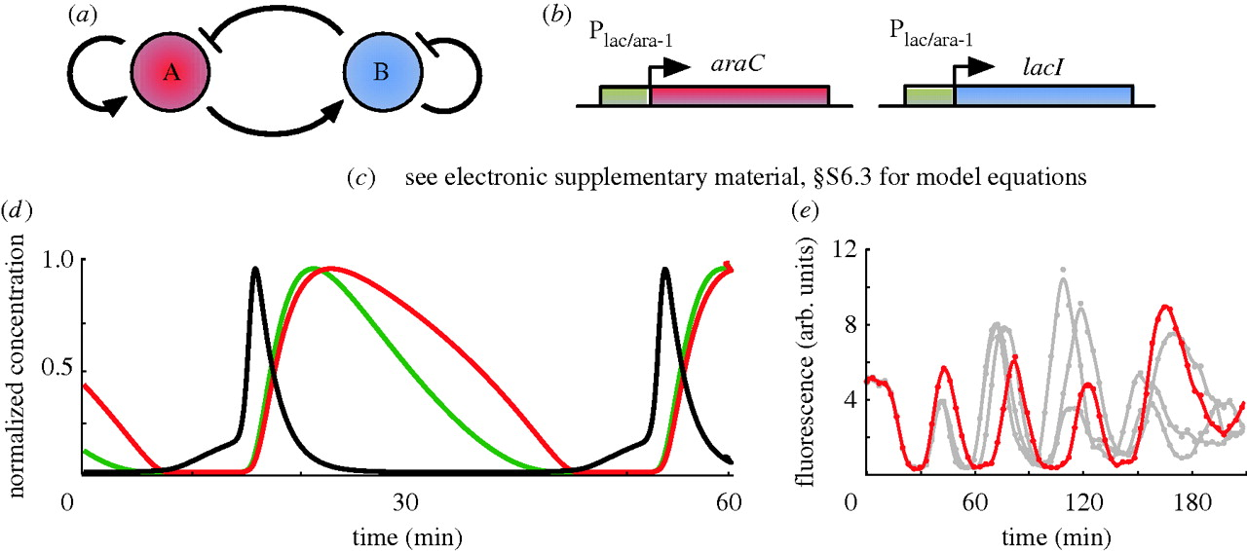

**Figure 7.**

(*a*) Smolen oscillator topology. Gene A activates its own transcription and that of gene B, while gene B represses its own transcription and that of gene A. (*b*) *In vivo* implementation. Details provided in the main text. (*c*) ODE model equations for the *in vivo* implementation are given in electronic supplementary material, §S6.3. (*d*) *In silico* simulation of ODEs for 0.7% arabinose and 2 mM IPTG. There red and green lines are LacI tetramers and AraC dimers, respectively. The black line is LacI mRNA. (*e*) Single-cell fluorescence trajectories, with 0.7% arabinose and 2 mM IPTG. Figure (*d*) and (*e*) are adapted from [**Stricker *et al.* (2008)**](http://rsif.royalsocietypublishing.org/content/7/52/1503#ref-48).

5.2.1.3器Variable link oscillators

A gene regulatory network is generally abstracted as a topology comprising a number of nodes connected by activating or repressing links. However, not all networks can be described in this way. For instance, the PRM promoter of the λ phage is controlled by cI at three operators: OR1, OR2 and OR3. Binding affinities are such that binding typically proceeds sequentially, OR1 before OR2, and OR2 before OR3 ([**Hasty et al. 2001a**](http://rsif.royalsocietypublishing.org/content/7/52/1503#ref-23)). Transcription is enhanced by cI binding to OR2, but repressed by binding to OR3; therefore, at low to medium cI concentrations, OR2 will be bound and transcription enhanced, while at high concentrations OR3 will also be bound, repressing transcription ([**Hasty et al. 2001a**](http://rsif.royalsocietypublishing.org/content/7/52/1503#ref-23)). The link formed by the regulation of this promoter is therefore variable.

This promoter has been used in an amplified negative feedback-like topology ([**figure 8**](http://rsif.royalsocietypublishing.org/content/7/52/1503#F8)a; [**Hasty et al. 2001a**](http://rsif.royalsocietypublishing.org/content/7/52/1503#ref-23)). The first gene regulates itself and a second gene, through the variable promoter, while repression by the second gene is via a protease acting on the product of the first gene. To study the network in silico, an ODE-based model was proposed in [**Hasty et al. (2001a)**](http://rsif.royalsocietypublishing.org/content/7/52/1503#ref-23) ([**figure 8**](http://rsif.royalsocietypublishing.org/content/7/52/1503#F8)c).

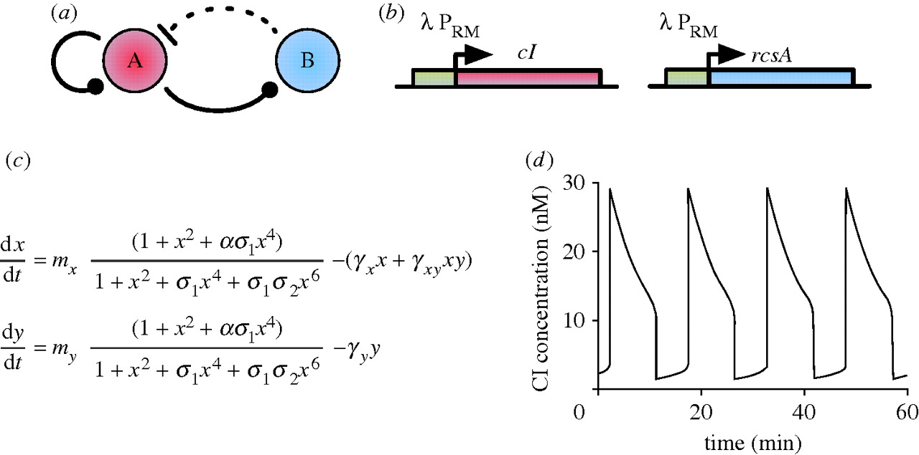

**Figure 8.**

(*a*) Variable link oscillator topology. At low concentrations of protein A, gene A promotes its own transcription and that of gene B, while at high A concentrations, A represses its own transcription and that of gene B. B is a protease and represses A by degradation. The variable links are denoted by a ball. Solid lines represent direct transcriptional control, while the dotted line represents the repression by proteolysis. (*b*) Possible *in vivo* implementation using the PRM promoter of the *λ* phage. Details provided in main text. (*c*) ODE model equations. *x* and *y* are dimensionless quantities of cI and RcsA, respectively, *t* is dimensionless time (see [**Hasty *et al.* (2001*a*)**](http://rsif.royalsocietypublishing.org/content/7/52/1503#ref-23) for details) and *mi* are the respective plasmid copy numbers. *σi* represents the relative affinities of cI dimer binding to OR1 relative to OR2 (*σ*1) and OR3 (*σ*3) binding. *α* is the degree to which transcription is enhanced by dimer occupation of OR2, while *γx* and *γy* capture degradation of cI and RcsA, respectively, and *γxy* represents the rate of cI degradation by RcsA. (*d*) *In silico* simulation of ODEs demonstrates oscillations. Figure (*d*) adapted from [**Hasty *et al.* (2001*a*)**](http://rsif.royalsocietypublishing.org/content/7/52/1503#ref-23).

5.2.1.3 代谢器Metabolator

The metabolator ([**Fung et al. 2005**](http://rsif.royalsocietypublishing.org/content/7/52/1503#ref-15)) is the first oscillator to be reported in the literature that incorporates metabolites as a core component. Conceptually, it comprises two genes. One gene produces an enzyme that converts one metabolic pool (M2) to another (M1); its transcription being activated by M2. At the same time, the other gene produces an enzyme that converts M1 to M2; its transcription being repressed by M2. Additionally, there is an influx into M1, and an efflux from M2 ([**figure 9**](http://rsif.royalsocietypublishing.org/content/7/52/1503#F9)a). To facilitate comparison with other oscillators, the topology of the metabolator can be represented schematically as a gene regulatory network ([**figure 9**](http://rsif.royalsocietypublishing.org/content/7/52/1503#F9)b). Here, two genes, A and B, activate each other and are self-repressed by increasing/decreasing the metabolic pool M2. A particular implementation of this concept ([**figure 9**](http://rsif.royalsocietypublishing.org/content/7/52/1503#F9)c) was modelled with ODEs (electronic supplementary material, §S7) and CLEs, which explicitly represent a GFP reporter ([**Fung et al. 2005**](http://rsif.royalsocietypublishing.org/content/7/52/1503#ref-15)). All following discussion refers to this model.

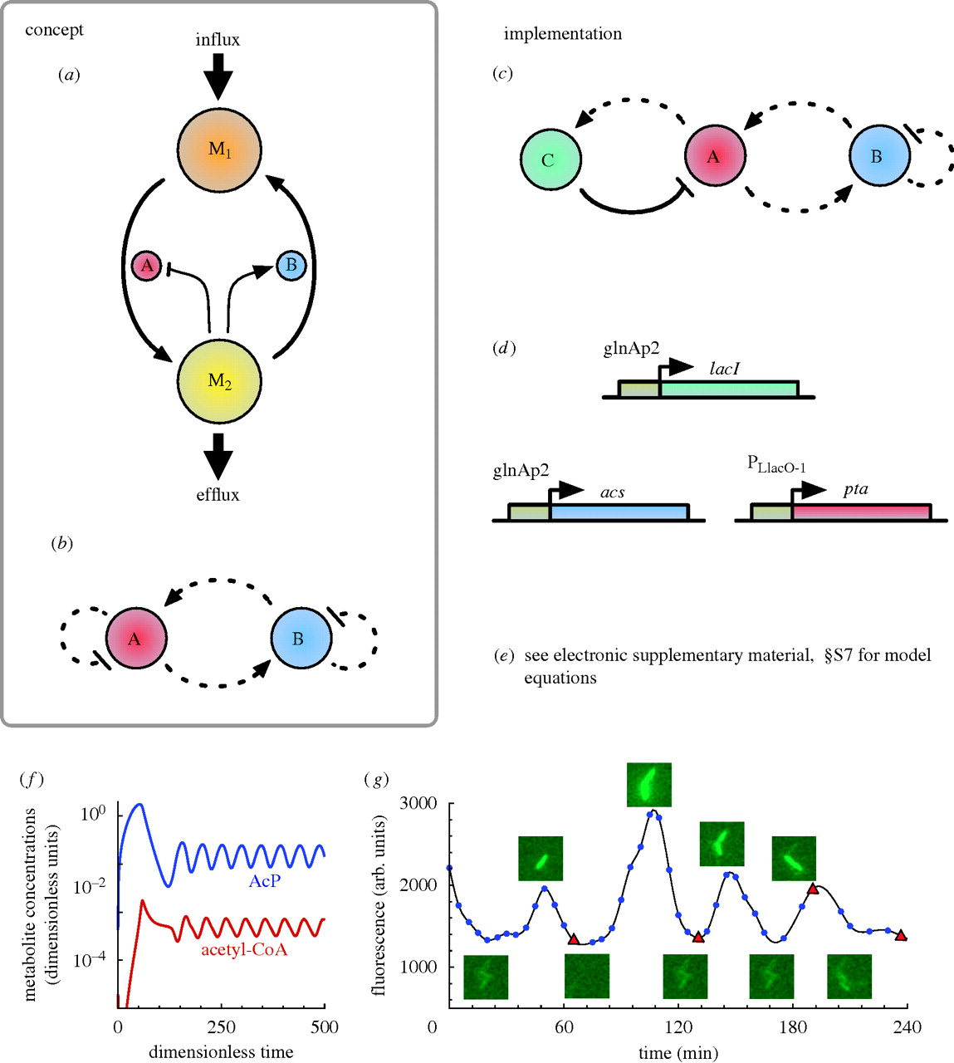

**Figure 9.**

(*a*) Metabolite-centric conceptual view of the metabolator. Gene A produces an enzyme that converts one metabolic pool (M1) to another (M2), its transcription repressed by M2, while gene B produces an enzyme that converts M2 to M1, its transcription activated by M2. In addition, there is an influx into M1 and an efflux from M2. (*b*) Schematic GRN diagram. Gene A represses itself (as it increases the level of M2, which represses it), while promoting gene B (it is activated by M2). Gene B also effectively represses itself (as it decreases the level of M2, which activates it), while effectively activating gene A (as M2 represses gene A). (*c*) Implementation topology. Three genes were used in the implementation. The negative feedback link from gene A to itself via gene C, is equivalent to gene A repressing itself in (*b*). Solid lines represent direct transcriptional control, while the dotted lines represent indirect repression. (*d*) *In vivo* implementation. Details are provided in the main text. (*e*) ODE model equations for the *in vivo* implementation are given in electronic supplementary material, §S7. (*f*) *In silico* simulation of ODEs with a relatively high glycolytic flux. (*g*) Single-cell fluorescence trajectories. Figures (*a*), (*f*) and (*g*) are adapted from [**Fung *et al.* (2005)**](http://rsif.royalsocietypublishing.org/content/7/52/1503#ref-15).

5.2.1.4 生理调节环路circadian circuits

5.2.2 设计的振荡器（designing oscillators）

* **5.3 逆变器inverters**

5.3.1 设计的逆变器（designing inverters）

* **5.4 趋化性和群体感应chemotaxis and quorum sensing**

5.4.1 细胞-细胞交流系统 cell-cell communication systems

* **5.5 合成基因网络的设计和特征 design and characterization of synthetic gene networks**

-协同表达coordinated expression

-表达的稳定性stability of expression

-转录级联transcriptional cascades

-开关toggles

-逻辑门logic gates

-信号放大signal amplifiers

-脉冲生成器pulse generators

# 6. 合成生物学生应用

* **6.1 合成生物学与健康**

青蒿素，一种抗疟药物，是通过合成生物学低价合成的典型药物之一。虽然中国使用这种中药（青蒿素）包括其作为退热剂的活性原理已经有超过2000年了，但是最近才获得它的纯化方法。现在青蒿素可以在大肠杆菌中合成，或者在酵母中合成前体后通过化学的方法转化成青蒿素[21][22]。磺胺类药物（抗菌剂），很多抗代谢抗癌药物，单克隆抗体像是曲妥单抗（用来治疗乳房癌），利妥昔单抗（用来治疗非霍奇金淋巴瘤）也是通过生物合成方法设计合成的药物。

* **6.2 合成生物学和环境**
* **6.3 合成生物学与新能源**

报道了一个用微生物直接从海藻酸生产生物乙醇的平台，原料是一种从海草中获得的多糖[23]。这个平台的主要进步在于对海藻酸的代谢相关酶进行生物改造，并且将其从灿烂弧菌转移到大肠杆菌，这样有利于工业应用。

* **6.4 合成生物学和新兴生物材料**

在最近的研究进展中，Wyss研究所(Wyss institute)的科学家创造了一种DNA纳米机器人，它可以实现在几乎无附带损伤（比如无正常细胞损害）的前提下靶向肿瘤细胞，并向其细胞表面释放抗癌药物(视频)。这种桶装分子在其桶装表面的两个适配子的帮助下牢牢闩在细胞表面，达到对靶细胞的特异识别效果，就像钥匙对锁的特异性识别一样。与细胞膜的结合引起桶装分子去折叠化，释放出桶装分子中的药物，这样就能防止药物与其他不表达“钥匙”的细胞作用。这种生物工程的概念被称作DNA折纸术（DNA origami），它可能还能用于除治疗以外的诊断工作。

* **6.5 纳米技术**
* **6.6 合成基因组学**

6.6.1 基因组改写和重构genome re-writing and refactoring

6.6.2 基因组移植genome transplantation

6.6.3 合成基因组和合成物种synthetic genomes and synthetic organisms

* **6.7 其他应用。**

# 7.

* **7.1 生物安全性**
* **7.2 合成生物学中的生物伦理学问题**
* **7.3 合成生命的新方法**

原型细胞，非DNA的遗传信息，非蛋白质酶类等。

* **7.4 合成生物学的未来。**

# 8. 资源

互联网上有许多合成生物学的优质资源。纽约州立石溪大学图书馆（Dana Antonucci-Durgan）开发了一个综合性的网站综合互联网资源。

* **8.1 DNA合成和测序**

-DNA序列翻译

-DNA-蛋白测序和合成工具

-技术概要：Illumina公司Solexa测序技术(论坛)

* **8.2 软件工具**

（点击标题可以获取不同的工具清单及描述。也可以见4.1计算模型）

* **8.3 教育资源：视频、综述、期刊、插件、新闻、漫画**

8.3.1 视频

-YouTube教程包括顶尖大学的合成生物学课程

-合成生物学的解释

-Andrew Hessel对合成生物学的介绍

-BBC：合成生物学

-KQED QUEST：破译合成生物学

-J. Craig Venter在NASA研究中心进行的合成生物学研究

-Drew Endy的合成生物学研究

-Drew Endy的工程生物学研究

-新型生物学

-Anthony Atala:打印人类肾脏

-DNA纳米机器人

8.3.2 回顾

-合成生物学的5个真理

-Science/AAAS|特殊问题：合成生物学

-Nature Biotechnology December 2009, Volume 27|关注合成生物学

-合成生物学焦点问题

-EMBO报道了特殊问题

8.3.3 期刊

-美国化学协会合成生物学

-生物工程

-计算机-定向分子设计

-合成生物学

-分子系统生物学

-系统和合成生物学

8.3.4 混搭

-theSynBioLogist

-SynBioFromLeukipposInstitute

8.3.5 新闻

-GEN-合成生物学

8.3.6 连环画

-合成生物学领域的冒险

8.3.7 IGEM基金/竞赛

国际基因工程机器基金专注于赞助合成生物学领域的创新，他们创建夏季大学生竞赛，竞赛内容为通过一系列的“组件”的组合来建立细胞内生物系统（生物积木）。这个竞赛与2003年在麻省理工学院以一个月的课程的形式首度开展，在2004年真正变为一个竞赛，并且在2011年成长为一个拥有165支来自全世界各地队伍的大型比赛。

8.3.8 社区

这部分包括非常有影响力的人、机构、公司、社会及专业网络平台，例如Facebook，LinkedIn，Menderly，Twitter。（细节请见标题）

* **8.4 合成生物学领域的毕业生**

一份有关在合成生物学方面设置毕业项目大学的清单

* **8.5 有影响力的文章**

文章请见标题，也可以在SynBio上找到一部分引用得最多的、最有影响力的文章。

## 参考文献

1. [**Synthetic biology: new engineering rules for an emerging discipline.**](http://www.wikigenes.org/e/ref/e/16738572.html) Andrianantoandro, E., Basu, S., Karig, D.K., Weiss, R. Mol. Syst. Biol. (2006) [[Pubmed](http://www.ncbi.nlm.nih.gov/entrez/query.fcgi?cmd=Retrieve&db=PubMed&dopt=Abstract&list_uids=16738572)]
2. [**Synthetic Biology: Bits and pieces come to life.**](http://www.wikigenes.org/e/ref/e/22378128.html) Collins, J. Nature. (2012) [[Pubmed](http://www.ncbi.nlm.nih.gov/entrez/query.fcgi?cmd=Retrieve&db=PubMed&dopt=Abstract&list_uids=22378128)]
3. [**Synthetic biology.**](http://www.wikigenes.org/e/ref/e/15995697.html) Benner, S.A., Sismour, A.M. Nat. Rev. Genet. (2005) [[Pubmed](http://www.ncbi.nlm.nih.gov/entrez/query.fcgi?cmd=Retrieve&db=PubMed&dopt=Abstract&list_uids=15995697)]
4. [**Knowledge-making distinctions in synthetic biology.**](http://www.wikigenes.org/e/ref/e/18081015.html) O'Malley, M.A., Powell, A., Davies, J.F., Calvert, J. Bioessays. (2008) [[Pubmed](http://www.ncbi.nlm.nih.gov/entrez/query.fcgi?cmd=Retrieve&db=PubMed&dopt=Abstract&list_uids=18081015)]
5. [**Piecing together a puzzle. An exposition of synthetic biology.**](http://www.wikigenes.org/e/ref/e/19415076.html) Deplazes, A. EMBO. Rep. (2009) [[Pubmed](http://www.ncbi.nlm.nih.gov/entrez/query.fcgi?cmd=Retrieve&db=PubMed&dopt=Abstract&list_uids=19415076)]
6. [**The second wave of synthetic biology: from modules to systems.**](http://www.wikigenes.org/e/ref/e/19461664.html) Purnick, P.E., Weiss, R. Nat. Rev. Mol. Cell. Biol. (2009) [[Pubmed](http://www.ncbi.nlm.nih.gov/entrez/query.fcgi?cmd=Retrieve&db=PubMed&dopt=Abstract&list_uids=19461664)]
7. [**Defossiling fuel: how synthetic biology can transform biofuel production.**](http://www.wikigenes.org/e/ref/e/18205286.html) Savage, D.F., Way, J., Silver, P.A. ACS. Chem. Biol. (2008) [[Pubmed](http://www.ncbi.nlm.nih.gov/entrez/query.fcgi?cmd=Retrieve&db=PubMed&dopt=Abstract&list_uids=18205286)]
8. [**Genetically modified organisms for the environment: stories of success and failure and what we have learned from them.**](http://www.wikigenes.org/e/ref/e/16200500.html) Cases, I., de Lorenzo, V. Int. Microbiol. (2005) [[Pubmed](http://www.ncbi.nlm.nih.gov/entrez/query.fcgi?cmd=Retrieve&db=PubMed&dopt=Abstract&list_uids=16200500)]
9. [**Environmentally controlled invasion of cancer cells by engineered bacteria.**](http://www.wikigenes.org/e/ref/e/16330045.html) Anderson, J.C., Clarke, E.J., Arkin, A.P., Voigt, C.A. J. Mol. Biol. (2006) [[Pubmed](http://www.ncbi.nlm.nih.gov/entrez/query.fcgi?cmd=Retrieve&db=PubMed&dopt=Abstract&list_uids=16330045)]
10. [**Synthetic biology approaches in drug discovery and pharmaceutical biotechnology.**](http://www.wikigenes.org/e/ref/e/20396881.html) Neumann, H., Neumann-Staubitz, P. Appl. Microbiol. Biotechnol. (2010) [[Pubmed](http://www.ncbi.nlm.nih.gov/entrez/query.fcgi?cmd=Retrieve&db=PubMed&dopt=Abstract&list_uids=20396881)]
11. [**A synthetic de-greening gene circuit provides a reporting system that is remotely detectable and has a re-set capacity.**](http://www.wikigenes.org/e/ref/e/17309732.html) Antunes, M.S., Ha, S.B., Tewari-Singh, N., Morey, K.J., Trofka, A.M., Kugrens, P., Deyholos, M., Medford, J.I. Plant. Biotechnol. J. (2006) [[Pubmed](http://www.ncbi.nlm.nih.gov/entrez/query.fcgi?cmd=Retrieve&db=PubMed&dopt=Abstract&list_uids=17309732)]
12. [**Cultivating plant synthetic biology from systems biology.**](http://www.wikigenes.org/e/ref/e/18373648.html) Bowen, T.A., Zdunek, J.K., Medford, J.I. New. Phytol. (2008) [[Pubmed](http://www.ncbi.nlm.nih.gov/entrez/query.fcgi?cmd=Retrieve&db=PubMed&dopt=Abstract&list_uids=18373648)]
13. [**Production of the antimalarial drug precursor artemisinic acid in engineered yeast.**](http://www.wikigenes.org/e/ref/e/16612385.html) Ro, D.K., Paradise, E.M., Ouellet, M., Fisher, K.J., Newman, K.L., Ndungu, J.M., Ho, K.A., Eachus, R.A., Ham, T.S., Kirby, J., Chang, M.C., Withers, S.T., Shiba, Y., Sarpong, R., Keasling, J.D. Nature. (2006) [[Pubmed](http://www.ncbi.nlm.nih.gov/entrez/query.fcgi?cmd=Retrieve&db=PubMed&dopt=Abstract&list_uids=16612385)]
14. [**Synthesizing life.**](http://www.wikigenes.org/e/ref/e/11201752.html) Szostak, J.W., Bartel, D.P., Luisi, P.L. Nature. (2001) [[Pubmed](http://www.ncbi.nlm.nih.gov/entrez/query.fcgi?cmd=Retrieve&db=PubMed&dopt=Abstract&list_uids=11201752)]
15. [**Studies on polynucleotides. 103. Total synthesis of the structural gene for an alanine transfer ribonucleic acid from yeast.**](http://www.wikigenes.org/e/ref/e/4571075.html) Khorana, H.G., Agarwal, K.L., Büchi, H., Caruthers, M.H., Gupta, N.K., Kleppe, K., Kumar, A., Otsuka, E., RajBhandary, U.L., Van de Sande, J.H., Sgaramella, V., Terao, T., Weber, H., Yamada, T. J. Mol. Biol. (1972) [[Pubmed](http://www.ncbi.nlm.nih.gov/entrez/query.fcgi?cmd=Retrieve&db=PubMed&dopt=Abstract&list_uids=4571075)]
16. [**Expression in Escherichia coli of a chemically synthesized gene for the hormone somatostatin.**](http://www.wikigenes.org/e/ref/e/412251.html) Itakura, K., Hirose, T., Crea, R., Riggs, A.D., Heyneker, H.L., Bolivar, F., Boyer, H.W. Science. (1977) [[Pubmed](http://www.ncbi.nlm.nih.gov/entrez/query.fcgi?cmd=Retrieve&db=PubMed&dopt=Abstract&list_uids=412251)]
17. [**Total synthesis of a human leukocyte interferon gene.**](http://www.wikigenes.org/e/ref/e/6167861.html) Edge, M.D., Green, A.R., Heathcliffe, G.R., Meacock, P.A., Schuch, W., Scanlon, D.B., Atkinson, T.C., Newton, C.R., Markham, A.F. Nature. (1981) [[Pubmed](http://www.ncbi.nlm.nih.gov/entrez/query.fcgi?cmd=Retrieve&db=PubMed&dopt=Abstract&list_uids=6167861)]
18. [**Emerging properties of animal gene regulatory networks.**](http://www.wikigenes.org/e/ref/e/21164479.html) Davidson, E.H. Nature. (2010) [[Pubmed](http://www.ncbi.nlm.nih.gov/entrez/query.fcgi?cmd=Retrieve&db=PubMed&dopt=Abstract&list_uids=21164479)]
19. [**Unbiased reconstruction of a mammalian transcriptional network mediating pathogen responses.**](http://www.wikigenes.org/e/ref/e/19729616.html) Amit, I., Garber, M., Chevrier, N., Leite, A.P., Donner, Y., Eisenhaure, T., Guttman, M., Grenier, J.K., Li, W., Zuk, O., Schubert, L.A., Birditt, B., Shay, T., Goren, A., Zhang, X., Smith, Z., Deering, R., McDonald, R.C., Cabili, M., Bernstein, B.E., Rinn, J.L., Meissner, A., Root, D.E., Hacohen, N., Regev, A. Science. (2009) [[Pubmed](http://www.ncbi.nlm.nih.gov/entrez/query.fcgi?cmd=Retrieve&db=PubMed&dopt=Abstract&list_uids=19729616)]
20. [**Systematic discovery of TLR signaling components delineates viral-sensing circuits.**](http://www.wikigenes.org/e/ref/e/22078882.html) Chevrier, N., Mertins, P., Artyomov, M.N., Shalek, A.K., Iannacone, M., Ciaccio, M.F., Gat-Viks, I., Tonti, E., DeGrace, M.M., Clauser, K.R., Garber, M., Eisenhaure, T.M., Yosef, N., Robinson, J., Sutton, A., Andersen, M.S., Root, D.E., von Andrian, U., Jones, R.B., Park, H., Carr, S.A., Regev, A., Amit, I., Hacohen, N. Cell. (2011) [[Pubmed](http://www.ncbi.nlm.nih.gov/entrez/query.fcgi?cmd=Retrieve&db=PubMed&dopt=Abstract&list_uids=22078882)]
21. [**Engineering a mevalonate pathway in Escherichia coli for production of terpenoids.**](http://www.wikigenes.org/e/ref/e/12778056.html) Martin, V.J., Pitera, D.J., Withers, S.T., Newman, J.D., Keasling, J.D. Nat. Biotechnol. (2003) [[Pubmed](http://www.ncbi.nlm.nih.gov/entrez/query.fcgi?cmd=Retrieve&db=PubMed&dopt=Abstract&list_uids=12778056)]
22. [**Production of amorphadiene in yeast, and its conversion to dihydroartemisinic acid, precursor to the antimalarial agent artemisinin.**](http://www.wikigenes.org/e/ref/e/22247290.html) Westfall, P.J., Pitera, D.J., Lenihan, J.R., Eng, D., Woolard, F.X., Regentin, R., Horning, T., Tsuruta, H., Melis, D.J., Owens, A., Fickes, S., Diola, D., Benjamin, K.R., Keasling, J.D., Leavell, M.D., McPhee, D.J., Renninger, N.S., Newman, J.D., Paddon, C.J. Proc. Natl. Acad. Sci. U. S. A. (2012) [[Pubmed](http://www.ncbi.nlm.nih.gov/entrez/query.fcgi?cmd=Retrieve&db=PubMed&dopt=Abstract&list_uids=22247290)]
23. [**An engineered microbial platform for direct biofuel production from brown macroalgae.**](http://www.wikigenes.org/e/ref/e/22267807.html) Wargacki, A.J., Leonard, E., Win, M.N., Regitsky, D.D., Santos, C.N., Kim, P.B., Cooper, S.R., Raisner, R.M., Herman, A., Sivitz, A.B., Lakshmanaswamy, A., Kashiyama, Y., Baker, D., Yoshikuni, Y. Science. (2012) [[Pubmed](http://www.ncbi.nlm.nih.gov/entrez/query.fcgi?cmd=Retrieve&db=PubMed&dopt=Abstract&list_uids=22267807)]

## 后记

待补充。

### 课程网址

http://www.cls.zju.edu.cn/binfo/lecture/2016/synbio

### 学生感言

！